Are you a Cereal Mixologist?
We want to see your culinary wizardry with milk and cereal!
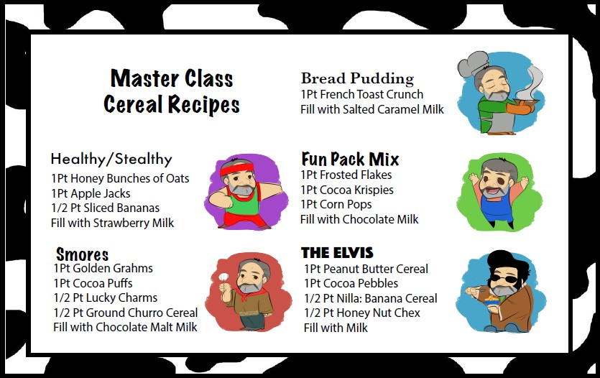

Receive a FREE cereal dispenser to serve these breakfast cereal combinations
October 1, 2019 until December 31, 2019

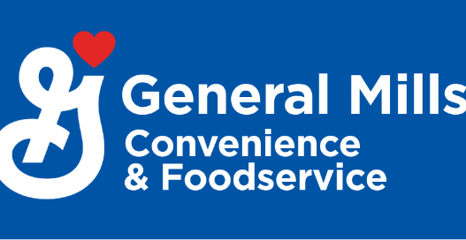
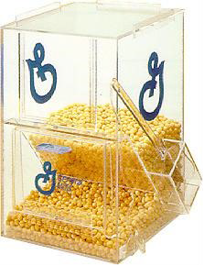
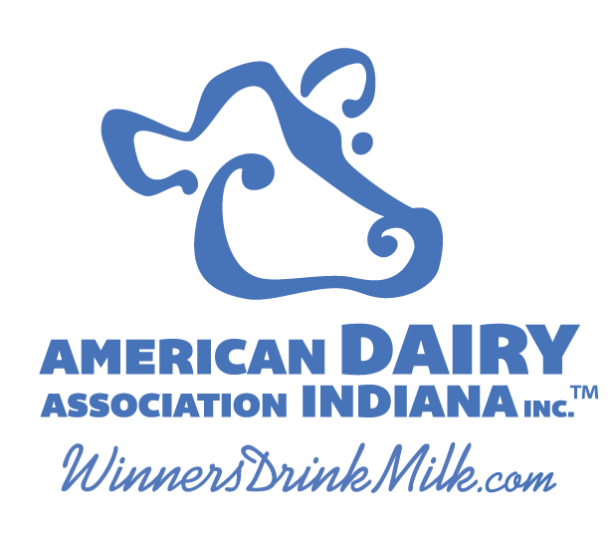

Details of Promotion:
General Mills and American Dairy Association (ADAI) have teamed up to give your school a cereal dispenser so you can implement recipes and inspire your breakfast crew.

What you need to do:
- Submit the following form to ADAI (Plummer@WinnersDrinkMilk.com) and General Mills (Sophia.Schnitzler@Genmills.com) .
Name of Foodservice Director: Email/Phone number: School: Address: Number of students enrolled: Idea of how to do this promotion: Dates of Promotional Run: Please provide testimonial of promotion and photos
Promotion runs from October 1, 2019 until December 31, 2019

- Purchase 90 cases of bulk General Mills cereal, General Mills cereal bowls or Yoplait yogurt (bowls and yogurt must be more than last year’s amount) to qualify.
- Provide beginning and ending ADP as it applies to the 3 month promotion -- each time cereal promotion is run.
- Submit all information, photos, testimonials and feedback to ADAI and General Mills by January 24, 2020 (we will use them for National School Breakfast Week!)
Be creative and make cereal fun!

To see the original cereal mixologist in action: http://bit.ly/CerealMixPromo

